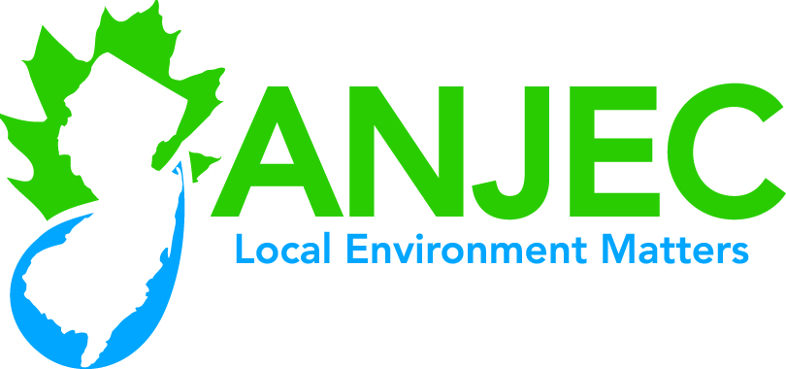

Septic System Resources



**ANJEC Septic System Resources**

ANJEC is a non-profit (501c-3) organization specializes in developing information for elected officials, environmental commissions, boards of health, planning boards and the general public on a variety of environmental issues. ANJEC takes care to write in a non-technical manner for these audiences. Septic education has been a staple of ANJEC resource development. All ANJEC Septic Resources are available for download and printing on-line at ANJEC.org. Some are available in limited hard copy format.

Resource Paper (2002) ***Septic Management for Clean Water***

<http://www.anjec.org/pdfs/RP_Septic.pdf> and black and white hard copy

This 11 page resource paper will be of interest to environmental commissions, boards of health, planning boards and elected officials. Homeowners will also find it of use. It is intended to provide the reader with a general understanding of septic systems, their functioning and maintenance requirements. Included are discussion of how septic systems work, why septic management, septic management, good environmental sense and a model septic ordinance.

Resource Paper (2017), ***Septic Systems, Clean Water and Your Municipality*** <http://anjec.org/pdfs/SepticSystems-2017.pdf> and limited numbers in hard copy format

This resource paper was developed primarily to educate municipal officials (elected officials, boards of health, environmental commissions and planning boards) although interested homeowners will find it of use. The paper is a full color 16 page discussion designed to make local officials aware of the signs of septic malfunction in the municipality, how to recognize failing systems, municipal obligations under the NJDEP’s Septic Rule (NJAC 7:9A) and their local ordinance, including homeowner education. The paper avocates the adoption of a local ordinance that requires a limited term operating license (3years) and proof of pump-out and inspection before the license is reissued. Five different levels of protection at the municipal level are discussed with stress on adopting “Level 3”. Links to adopted municipal “Level 3” ordinances are provided and a listing of homeowner education materials with links is provided. An extensive glossary of terms and listing of resources is provided.

Power Point Presentation: ***Septic Systems, Clean Water and your Municipality*** <http://anjec.org/pdfs/Presentation-Septic%20SystemsClean%20WaterandYourMunicipality.pdf>

Available as a PDF file on the ANJEC website and as a Power Point by calling David Peifer at ANJEC (973-539-7547), this 27 slide presentation is designed for an audience of municipal officials although homeowners may also find it of interest. It can be used as a training resource for elected officials, environmental commissions, boards of health, and planning boards.

*These resources made possible by a grant from the William Penn Foundation*

